


Templates for Public Notice of Intention to apply for a Betting Licence

Contents
Notice of Intent Templates 3
Public notice of intention to apply for a remote betting licence 3
Public notice of intention to apply for a remote betting intermediary licence 4
Public notice of intention to apply for in-person licence for betting from a non-relevant premises (i.e. a “high street” or “off course” bookmakers office) 5
Public notice of intention to apply for a remote betting licence and an in-person betting licence 7

Notice of Intent Templates
The following templates should be used to signal your intent to apply for a betting licence. Use these templates in conjunction with the guidelines published on the GRAI website.

Public notice of intention to apply for a remote betting licence
Notice is hereby given under section 95 of the Gambling Regulation Act 2024 that following the expiry of 28 days of the date of publication of this notice, [name of the proposed licensee], of [address of the proposed licensee’s main office or place of business or registered address], intends to apply for a remote betting licence.
Dated this [date of publication]
[Name of the individual responsible for publication of the notice]
On behalf of [name of the proposed licensee]
Example:
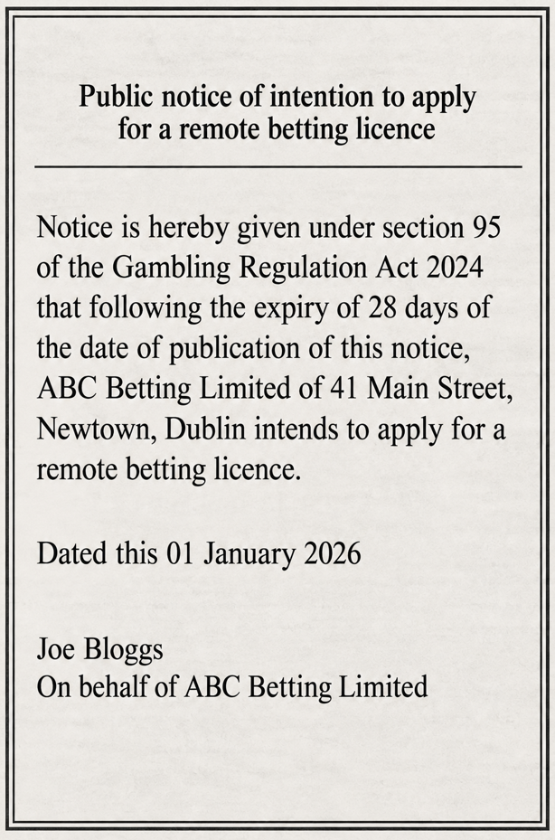

Public notice of intention to apply for a remote betting intermediary licence
Notice is hereby given under section 95 of the Gambling Regulation Act 2024 that following the expiry of 28 days of the date of publication of this notice, [name of the proposed licensee], of [address of the proposed licensee’s main office or place of business or registered address], intends to apply for a remote betting intermediary licence.
Dated this [date of publication]
[Name of the individual responsible for publication of the notice]
On behalf of [name of the proposed licensee]

Example:
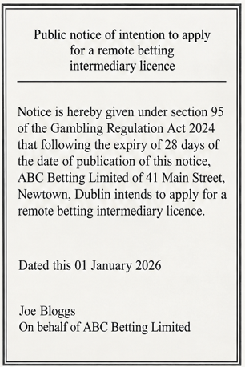

Public notice of intention to apply for in-person licence for betting from a non-relevant premises (i.e. a “high street” or “off course” bookmakers office)
Notice is hereby given under section 95 of the Gambling Regulation Act 2024 that following the expiry of 28 days of the date of publication of this notice, [name of the proposed licensee], of [address of the proposed licensee’s main office or place of business or registered address](the “Proposed Licensee”), intends to apply for an in-person betting licence.
The gambling activity sought to be licensed is proposed to be provided by the Proposed Licensee from the following premises in the State:
[address or information sufficient to enable clear identification of the location of the premises], situated in the local authority area of [name of local authority].
Dated this [date of publication]
[Name of the individual responsible for publication of the notice]
On behalf of [name of the Proposed Licensee]

Example:
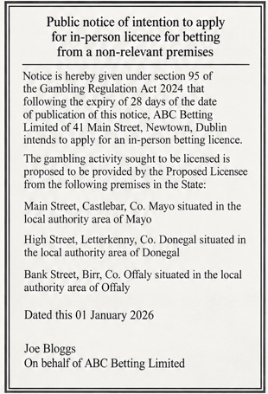
Public notice of intention to apply for in-person licence for betting from relevant premises only (i.e. on course)
Notice is hereby given under section 95 of the Gambling Regulation Act 2024 (the “Act”) that following the expiry of 28 days of the date of publication of this notice, [name of the proposed licensee], of [address of the proposed licensee’s main office or place of business or registered address] (the “Proposed Licensee”), intends to apply for an in-person betting licence.
The gambling activity sought to be licensed is proposed to be provided by the Proposed Licensee from relevant premises (within the meaning of section 2 (1) of the Act) only.
Dated this [date of publication]
[Name of the individual responsible for publication of the notice]
On behalf of [name of the Proposed Licensee]

Example:
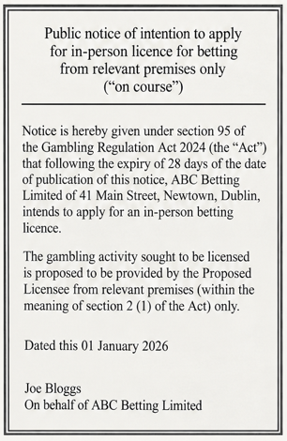

Public notice of intention to apply for a remote betting licence and an in-person betting licence
Notice is hereby given under section 95 of the Gambling Regulation Act 2024 that following the expiry of 28 days of the date of publication of this notice, [name of the proposed licensee], of [address of the proposed licensee’s main office or place of business or registered address] (the “Proposed Licensee”), intends to apply for an in-person betting licence and a remote betting licence.
The gambling activity sought to be licensed by the in-person betting licence is proposed to be provided by the Proposed Licensee from the following premises in the State:
[address or information sufficient to enable clear identification of the location of the premises], situated in the local authority area of [name of local authority].
Dated this [date of publication]
[Name of the individual responsible for publication of the notice]
On behalf of [name of the Proposed Licensee]
Example:
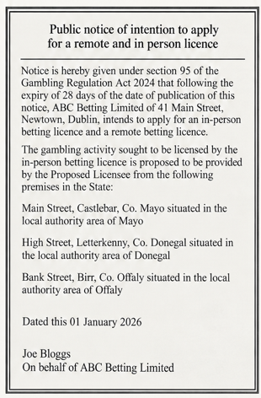

List every premises to which the licence will apply
Hybrid licences are not available as of yet. This is a template to provide notice of two separate applications: one for remote betting, the other for in-person betting
List every premises to which the licence will apply

